Y3 Maths, Friday 26th June.
Next week you are going to start a new unit on angles and shapes.
Check you have remembered your shapes learning from Y2 by completing the tasks below. You could do the drawing task (number 4) as a challenge with a parent or sibling. Read out the instructions and see if you both draw the same thing. Add colours to your instructions if you want to make the task more difficult!

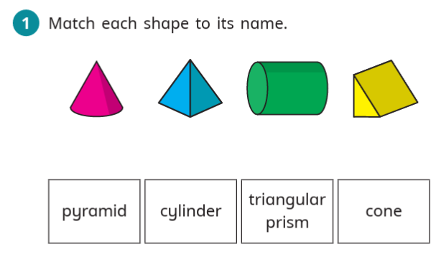

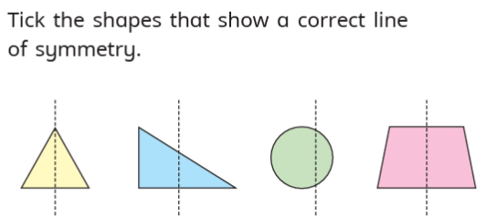


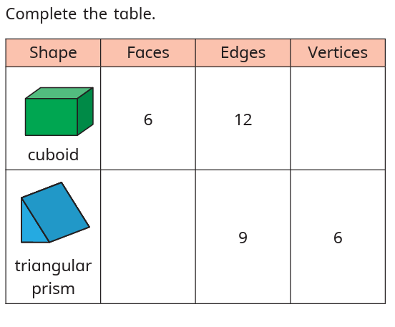


 Draw the patterns as described.



