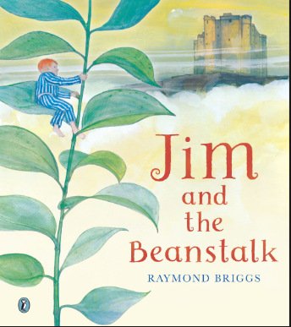
Literacy activities for home learning.
In Hedgehog Class, we have been reading the book “Jim and the Beanstalk” by Raymond Briggs.
We have been comparing this story with the traditional story of Jack at the Beanstalk.
If you would like to listen to the story, here is the link to a YouTube retelling of it:
https://youtu.be/L-FVBoj9kOY?si=0TftAYrvmeKPZKYz
If you would like to extend our learning, I have designed two pieces of work for you to complete over the next two days.

Activity 1: Character Description – “Meet the Giant!”
Write 4–6 sentences describing the giant Jim meets at the top of the beanstalk.

Success Criteria
- Use adjectives to describe the giant.
- Write in full sentences.
- Describe what the giant looks like, sounds like, and acts like.

Sentence Starters
- The giant has…
- He looks…
- He sounds…
- He is a giant who…

Activity 2: Letter Writing – “A Letter from Jim”
Write a short letter from Jim to his mum explaining what happened when he climbed the beanstalk.

Include in Your Letter
- A greeting
- What happened first, next, then, finally
- How Jim felt
- A closing line and name

Sentence Starters
- Dear Mum,
- First I climbed…
- Next I met…
- I felt… because…
- From Jim

Optional Extras
- Add a drawing of the giant.
- Add a picture of Jim climbing the beanstalk.

