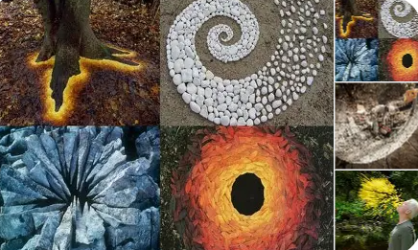

In Art we have been looking at the work of Andy Goldsworthy. Here is an activity you might like to try if you have time:

Step 1 — Collect Natural Materials
Go outside to your garden or on a short walk. Collect items that have already fallen to the ground, such as:
- Leaves
- Sticks
- Stones
- Petals
- Pinecones
- Grass
Do not pick anything still growing.

Step 2 — Sort Your Materials
Sort your items into groups:
- By colour
- By size
- By shape
This will help you plan your artwork.

Step 3 — Create Your Artwork
Choose one idea below or invent your own:
- Make a spiral using leaves or stones
- Make a circle using sticks or petals
- Make a line that bends or zig-zags
- Make a colour pattern from light to dark
Arrange your materials carefully. Take your time.

Step 4 — Take a Photo
Andy Goldsworthy’s art doesn’t last forever. Take a photo of your artwork to keep it safe.

Step 5 — Reflect on Your Art
Answer these questions:
- What shape or pattern did you make?
- Which materials did you enjoy using the most?
- How did your artwork change the space around it?
- What would you try next time?

