Superheroes  Including real life superheroes  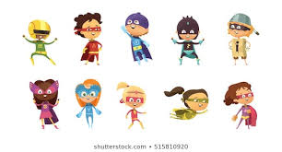 | Derry Hill  C of E Primary School | Dormouse Class  Year R: Term 5 Summer 2026
Area of Learning | Key Vocabulary | Skills and Knowledge | Intent and Implementation
Personal, Social and Emotional Development  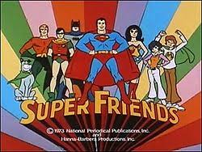 | - Instruction  - Attention  - Distraction  - Feelings (including feeling words such as worried, angry, tired)  - Perseverance  - Resilience  - Confidence  - Independent  - Respect  - Cooperate  - Sensitive | - To show an understanding of their own feelings, and begin to regulate their behaviour accordingly.  - Give focused attention to what the teacher says, responding appropriately, even when engaged in an activity.  - Show independence, resilience and perseverance in the face of challenge.  - Work and play cooperatively, take turns with other. | Our personal, social and emotional development is embedded into every aspect of our everyday play and learning.  We will look at the healthy lifestyle of superheroes and use that to learn about the importance of a healthy lifestyle. We will try new foods, discuss the benefits of them and think about how much exercise impacts us.  Later in the term, we will be learning about everyday heroes who help us, such as doctors, nurses, firefighters, paramedics and police officers. We also will undertake circle times, to support our personal, social and emotional development, as and when the need requires.
Communication and Language 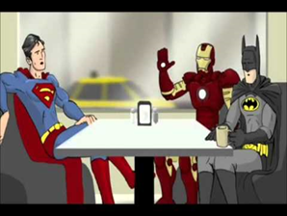 | - Question  - Answer  - Listen  - Attention  - Conversation  - Discussion  - Vocabulary  - Explain | - Respond to what we hear with relevant questions, comments and actions. Asking questions to clarify our understanding.  - Offer our own ideas in 1:1, small group and whole class discussions.  - Use recently introduced vocabulary.  - Express our ideas and feelings about our own experiences.  - Explain why things might happen, using newly learnt vocabulary. | We will all create our own superhero characters, talk about and explain our own superpowers, make costumes/disguises and super-gadgets. We will be thinking about questions that we would like to ask our favourite superhero and what our superpower would be if we had one.  We will spend time in our people who help us role-play, catching criminals in our police station and looking after people in our hospital.
Physical Development  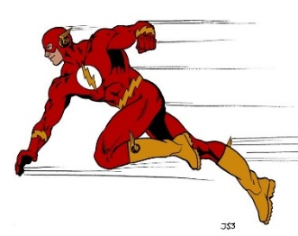 | - Balance  - Travel  - Direction  - Turn  - Speed  - Control  - Coordination  - Throw/catch/aim/roll  - Exercise  - Tripod  - Formation  - Posture | - Develop confidence, precision and accuracy when engaged in activities that involve a ball.  - Be able to balance, on and off equipment.  - Be able to jump safely from a piece of equipment.  - Hold a pencil effectively, using the tripod grip in almost all cases.  - Use a range of small tools. | The children’s physical development is embedded into our everyday learning and play. In addition to this, we will be moving like a superhero, adding movements and dances to superhero songs and music. We will also be further developing our ball skills through a range of activities that include throwing, catching, kicking, passing, batting, and aiming. This term we will undertake In2Sports in our second PE session where we will be learning lots of new skills as well as working in a team.
Expressive Arts and Design  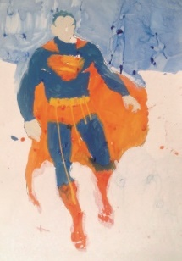 | - Background  - Texture  - Outline  - Colour  - Light  - Dark  - Mix  - Music  - Instrument  - Lyrics  - Beat  - Rhythm | - Safely use and explore a variety of materials. Tools and techniques, experimenting with colour, design, function and form.  - Share our creations, exploring the processes we have used.  - Make use of props and materials when role-playing characters in narratives and stories.  - Play a range of percussion instruments.  Use instruments to compose own music. | We will be thinking about what superheroes need; a disguise, gadgets, a superhero hideout, a super vehicle. We will make these using a variety of resources, materials and media, working both collaboratively and independently.  We will construct superhero cities using various resources and put our cutting and sticking skills to the test to create real life superhero vehicles. We will be drawing and painting superheroes from stories as well as superheroes in our own lives! We will listen to a variety of music; learn some new songs and we will use instruments to explore sound and music.
Understanding the World  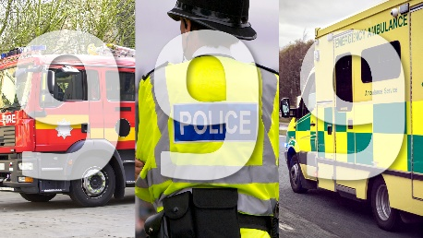 | - Community  - Similarities  - Differences  - Paramedics  - Fire fighters  - Ambulance  - Police officer  - Map  - Family  - Same/different | - Describe their immediate environment using knowledge from observation, discussion, stories, non-fiction texts and maps.  - Know some similarities and differences between different communities  - Explain some similarities and differences between life in this country and life in other countries, drawing on knowledge from stories, nonfiction texts and (when appropriate) maps. | We will be learning about the people all around us who help on a daily basis and thinking about how they help our community. We will discuss why these people are so important and why they are needed all across the world. We will explore how these people and the things they use (vehicles, hospitals etc) and how this might look different elsewhere as well as how this looked different in the past.

