Wild World  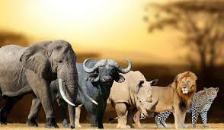 | Derry Hill  C of E Primary School | Dormouse Class  Year R: Term 4 Spring 2026
Area of Learning | Key Vocabulary | Skills and Knowledge | Intent and Implementation
Personal, Social and Emotional Development  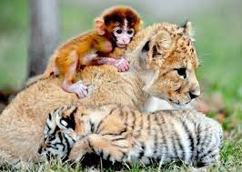 | - Instruction  - Attention  - Distraction  - Feelings (including feeling words such as worried, angry, tired)  - Independent  - Respect  - Cooperate  - Confidence  - Sensitive | - To think about the perspective of others.  - Complete set challenges/tasks independently and with more confidence.  - Identify and moderate our own feelings socially and emotionally.  - Express our own feelings and consider the feelings of others.  - Cooperate with others, listening and sharing ideas, using words to solve conflicts and disagreements. | Our personal, social and emotional development is embedded into our everyday play and learning. This term we will be using stories to help us understand our own feelings more, learn how to show sensitivity to one another’s needs, resolve conflicts, and understand when we do or don’t need help. We will continue to undertake additional circle time when the need arises.
Communication and Language  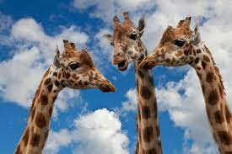 | - Question  - Answer  - Listen  - Attention  - Conversation  - Discussion  - Vocabulary  - Explain  - Re-tell | - To ask questions to find out more and to check we understand what has been said to us.  - Listen to and talk about non-fiction books, enabling us to develop new knowledge and vocabulary  - Respond to discussions with comments and questions.  - Enjoy being part of conversations and discussions, using new vocabulary in context.  - Use talk to support our imaginative play. | We will talk about the texts we read together, developing our vocabulary and comprehension skills through predicting, explaining and sequencing. We will think about questions and develop our questioning skills with the help of a variety of animals.  Within our role play areas and small world activities, both inside and out, we will be creating our own adventures using stories and poems as a guide. We will be using puppets, dressing up clothes and small world resources. Our topic-based role-play will be Wild World Safari, including our own Safari Jeep!
Physical Development  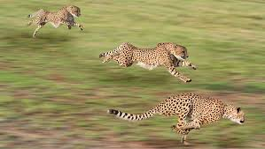 | - Balance  - Travel  - Direction  - Speed  - Control  - Throw/catch/aim/roll  - Exercise  - Snip/Cut  - Curved  - Straight  - Tripod  - Formation | - Further develop a range of ball skills.  - Be able to balance, on and off equipment.  - Be able to jump safely from a piece of equipment.  - Develop the foundations of a handwriting style which is fast, accurate and efficient.  - Use scissors to cut around more complex shapes. | Our physical development, both gross and fine motor skills, is embedded in our everyday learning and play. We will continue to develop our fundamental skills, during our PE sessions. For our second PE session, we will have a jungle theme and will continue to develop our balance skills.
Expressive Arts and Design  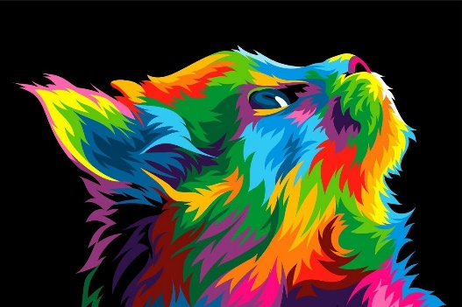 | - Colour mixing  - Primary colours  - Light  - Dark  - Materials  - Join  - Combine  - Background  - Outline  - Music  - Instrument  - Percussion  - Beat | - Use different techniques and materials to achieve the desired effect, talk about what we have created.  - Mix colours to produce different colours and shades and combine materials to create different textures.  - Begin to plan a design before starting, use a range of tools and equipment, selecting the most appropriate tool or joining material for the job.  - Explore and engage in music.  - Play a range of percussion instruments.  - Use instruments to compose own music. | There will be many creative activities available such as mask making, painting animal prints, magazine cut out suitcases, using play dough to make different animals, making collage and 3d animals, amongst many other things. We will also use the instruments to make sounds to match different animals and have a go at moving like various animals. We will explore our new ‘safari’ role-play and experiment with various dressing up and animal themed puppets.
Understanding the World  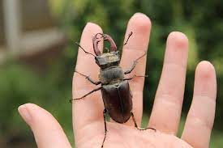 | - Habitat  - Environment  - Land  - Sea  - Forest  - Countryside  - Desert  - Mountain  - Animals  - Carnivore  - Herbivore  - Camouflage  - Nocturnal  - Differences  - Similarities  - World  - Country  - Map  - Globe | - To describe what we see, hear and feel whilst outside.  - Recognise some environments that are different to the one in which we live.  - Understand and use some language related to animal’s e.g. carnivore, herbivore, and camouflage, predator, nocturnal and diurnal.  - Develop our general knowledge about living things and the natural world, describing features of different plants and animals, recognising when they are the same and different.  - Recognise that people have different beliefs and celebrate different times in different ways. | We will develop our understanding and knowledge of wild animals and our world through books, the internet and video clips. We will also explore the animals we have on our doorstep, go mini-beast hunting outside, investigate and compare what we find.  We will continue to find out about the different places and countries that people live, as well as the various places we have all visited around the world.  We will be learning about the Christian celebration Easter, including why we celebrate Palm Sunday.

