Your plans for a greener future
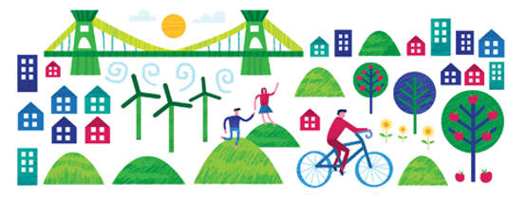
Once you have planned your city, making sure that you have found suitable locations for all significant buildings and landmarks, it is time to start planning for the future.
Here you will write your Green City Charter. Based on your five aims you need to clearly state what you are going to do and explain how the residents of your city will benefit from your new proposals.
Energy - Your aim: To be the first city in world to use 100 per cent renewable energy.
You need to produce your electricity using sustainable, green technique such as wind power, solar power and hydro power. Maybe you can even think of your own unique way of generating energy.
Food - Your aim: Reduce your food miles.
You want to encourage the people of your city to reduce the distance their food has travelled to reach their plate. People will need to eat seasonal, locally produced food. Can you change their habits and inspire communities to grow their own fruit and vegetables?
Nature - Your aim: Bring nature back to the city
Plants and animals are an important part of all of our lives and something that often gets overlooked in a busy city environment. How can you squeeze more green space into a jam packed urban jungle?
Transport - Your aim: Fewer cars and cleaner air
We are all familiar with the frustration of being stuck in a traffic jam and we all know that cars use fossil fuels which are harmful to our environment. Can you persuade people to use an alternative method of travel to get around? Maybe you can encourage the use of transport powered by renewable energy.
Waste - Your aim: Reduce, reuse and recycle
You need to make sure that the people in your city are doing all they can to produce less waste. Whether it is by reducing food waste and packaging, reusing items such as clothes and bags or by making sure the waste they do produce is recycled and turned into something which will be useful in the future.

