To infinity and beyond  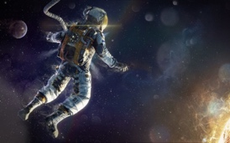  What will we see if we travel into space? | Derry Hill  C of E Primary School | Dormouse Class  Year R: Spring Term 3 2026
Area of Learning | Key Vocabulary | Skills and Knowledge | Intent and Implementation
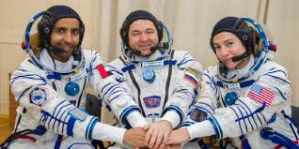  Personal, Social and Emotional Development | - Feelings  - Independent  - Respect  - Instruction  - Big Problems  - Little Problems  - Cooperate | - Continue to build constructive and respectful relationships.  - Develop our ability to express our feelings and consider the feelings of others.  - Continue to develop resilience and perseverance.  - Identify and moderate our own feelings socially and emotionally.  - Think about the perspective of others. | Our personal, social, and emotional development is embedded into our everyday learning and play.  We will also be thinking about how we can work and play together (co-operate and collaborate). We will be thinking about how it would feel to go to the moon or out into space. We will link this with activities and discussions about our everyday feelings. We also will undertake circle times, to support our personal, social and emotional development, as and when the need requires.  We will be exploring E-Safety throughout our PSHE lessons this term.
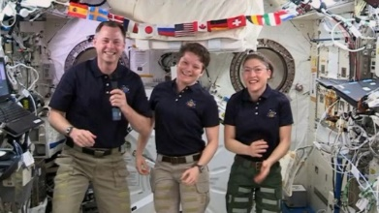  Communication and Language | - Question(s)  - Answer  - Listen  - Attention  - Vocabulary  - Explain | - To ask questions to find out more.  - Use talk to help work out problems and organise thinking and activities, and to explain how things work and why they might happen.  - Continue to describe events in some detail.  - Begin to use past, present and future forms accurately when talking about events that have happened or are to happen in the future.  - Learn some new vocabulary linked to space, planets and the solar system. | We will be thinking about questions that we would like to ask an astronaut to help us find out more about space and space travel. Our role-play area will be a Space Station. We will also have a variety of ongoing activities such as small world activities and creative and messy play which support all areas of communication and language. During our alien focus weeks, we will be describing aliens, using many wonderful adjectives. We will be thinking about how we could describe ourselves to an alien. We will be exploring, asking, and answering questions about space. We will be sharing facts we have learnt about the moon and planets, using our knowledge to create a space fact file and developing our newly learnt vocabulary through stand up stories.
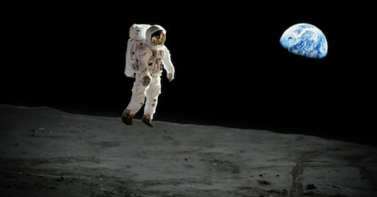  Physical Development | - Space  - Balance  - Travel  - Stop/start  - Hop  - Exercise  - Snip/Cut  - Curved  - Straight  - Grip  - Control  - Dance  - Movement | - Develop body strength, control, co-ordination, balance and agility.  - Confidently and safely, use a range of large and small apparatus, including jumping safely from a piece of equipment.  - Develop fine motor skills and begin to be able to use a range of tools competently, safely and confidently. | The children’s physical development is embedded into our everyday learning and play. We will be developing both our static balance skills and our balance when jumping and landing, during our PE lessons. This will be undertaken through Real PE and the unit Moon Adventure. We will also develop our control, co-ordination and body rhythm through a series of Drumba lessons.  Within the classroom environment, the children will continue to develop their fine motor skills with our Funky Finger challenges and through using a variety of tools and techniques in our creative area. Gross motor skills will be strengthened outside when using a variety of resources and equipment such as; the climbing frame, bikes, balls, brushes, red domes, and water play.
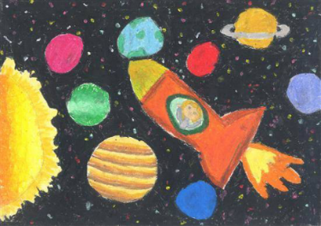  Expressive Arts and Design | - Colour  - Colouring mixing  - Primary Colours  - Light  - Dark  - Materials  - Join  - Combine  - Shapes  - Music | - Begin to plan a design before starting, using a range of tools, equipment and techniques.  - Create collaboratively, sharing ideas, resources and skills.  - Mix colours to produce different colours and shades.  - Explore and engage in music.  - Play a range of percussion instruments. | We will be creating a space themed display to go with our Space Station role play. We will be combining our maths learning with our creative learning by making some 2d and 3d shape rockets. We will be learning about the primary colours and doing some colour mixing; making different colour aliens to match them up with the correct planets. We will also use our imagination to design and create our own alien space stations using a range of different materials and media. We will continue to develop our music skills through our music and PE lessons this term.
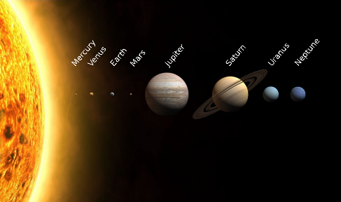  Understanding the World | - Past/Present  - Moon (landing)  - Earth  - Solar System  - Planets  - Sun  - Stars  - Differences  - Similarities  - World  - Country  - Map  - Globe | - To learn about the historical event; the first moon landing, and how things were different in the past  - To name some of the planets in the solar system.  - Describe what we see, hear and feel.  - Recognise some similarities and differences between countries around the world.  - Recognise that people have different beliefs and celebrate special times in different ways. | We will be learning lots of facts about the moon and the planets. We will look at and compare different planets, identifying the similarities and differences between them. We will also learn about the first moon landing. We will be using the BeeBots (programmable robots) to send them on a journey into space.  At the end of the term, we will learn about Chinese New Year through various videos, stories, role play and art and craft activities.

