Once upon a time  Can you find another way for the Billy Goats to cross the river?  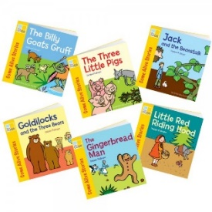 | Derry Hill  C of E Primary School | Year R: Term 2 Autumn 2025
Area of Learning | Key Vocabulary | Skills and Knowledge | Intent and Implementation
Personal, Social and Emotional Development  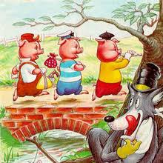 | - Feelings  - Independent  - Respect  - Instruction  - Distraction  - Big Problems  - Little Problems  - Cooperate | - Continue to build constructive and respectful relationships.  - Express our feelings and consider the feelings of others.  - Identify and moderate our own feelings socially and emotionally.  - Think about the perspectives of others. | We will be using stories to promote discussion about our feelings, being sensitive to one another’s feelings, and co-operating and sharing with one another.  The children’s independence will continue to be developed with the introduction of our must do’s, an activity the children have to undertake by themselves. Discussions and circle times will occur as and when they are needed to support our personal, social and emotional development.
Communication and Language  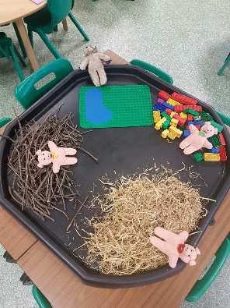 | - Traditional Tales  - Story  - Characters  - Once upon a time  - Question  - Answer  - Retell  - Vocabulary  - Expression | - Listen to and talk about stories, building familiarity and understanding.  - Learn, and develop, some of the vocabulary from the stories we read.  - Talk about what happens in each story.  - Re-tell and act out some stories, using the correct story language. Including the nativity story. | Our role-play will be adapted to suit our new topic – Once Upon a Time! We will have a variety of resources and dressing up clothes linked to the story’s we are reading, enabling the children to act them out, develop their own narratives, and use expressive language and intonation. We will also use puppets and small world resources to retell stories and create our own narratives.
Physical Development  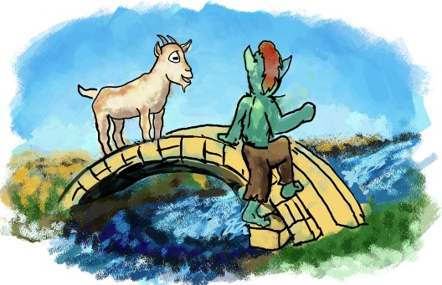 | - Space  - Balance  - Travel  - Stop/start  - Hop  - Exercise  - Snip/Cut  - Curved  - Straight  - Letters/formation | - Develop body strength, control, co-ordination, balance and agility.  - Develop fine motor skills and begin to be able to use a range of tools competently, safely and confidently.  - Confidently and safely, use a range of large and small apparatus. | We will continue developing our fundamental movement skills during our PE lessons. We will also be developing our multi-skills using traditional tales, for example building and crossing bridges like the Three Billy Goats Gruff.  We will continue to develop both our fine and gross motor skills through the variety of resources we have indoors and outside.
Expressive Arts and Design   | - Colour  - Join  - Combine  - Shapes  - Background  - Retell  - Characters  - Story  - Music  - Dance  - Movement | - Explore, use and refine a variety of artistic effects to express our ideas and feelings.  - Create collaboratively, sharing ideas, resources and skills.  - Develop storylines in our pretend play.  - Listen attentively, move to and talk about music, expressing our feelings and responses. | We will be designing and making our own houses and bridges using junk modelling, construction and the resources we have in our outside classroom. The children will also have the opportunity to develop their own ideas in the creative area, using a variety of materials and tools. We will draw firework pictures and undertake lots of Christmas crafts! We will also be having lots of fun with music and songs, including practise for our upcoming nativity.
Understanding the World  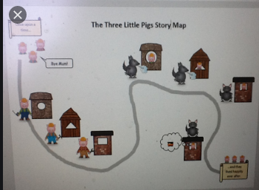 | - Long ago  - Differences  - Similarities  - World  - Country  - Map  - Globe  - Religion  - Celebration  - Family | - Develop simple mapping skills through drawing a story map, showing the different places the characters visit.  - Talk about the past using stories, images and videos to help us.  - Recognise that people have different beliefs and celebrate special times in different ways.  - Learn about the celebration: Christmas, talking about how and why it is celebrated. | We will look at story maps and use them to help us make our own map of a story we are focussing on. We will continue to explore and investigate using our outdoor classroom and our curiosity tables indoors. We will spend some time learning about Christmas, what this means to Christians and reading the Nativity story. We will also be learning about Remembrance Day and Bonfire Night, in an age appropriate way.

