Derry Hill C of E Primary School
Long Term Curriculum Design – Squirrel Class (Year 3) 2025-26
Term | Autumn 1 | Autumn 2 | Spring 1 | Spring 2 | Summer 1 | Summer 2
Key Question | How did the Stone Age Survive?  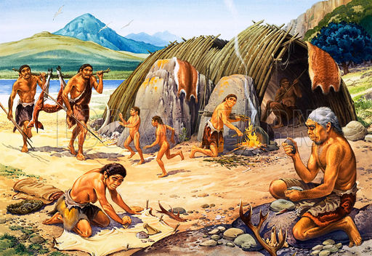 | What makes the Earth Angry?  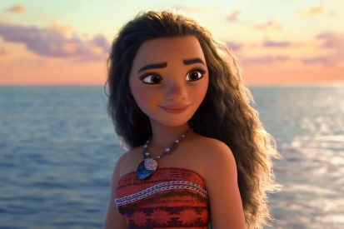 | What do you need for a marvellous medicine?  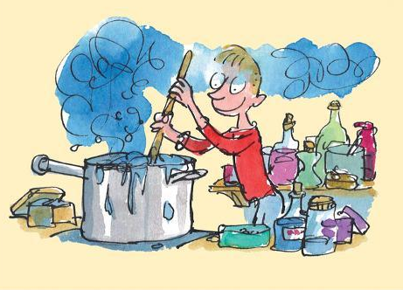 | Who were the Egyptians?  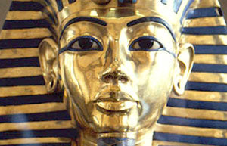 | Where in the world might you find a dragon?  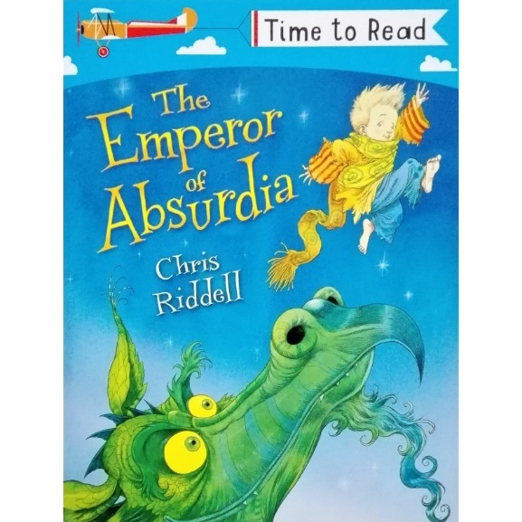 | 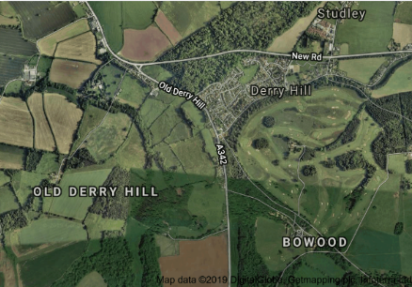  What’s so special about our local area?
Launch | Forest Visit – Build a shelter | Watch Moana | Spectacular Science | Trip to the Ashmolean Museum | Jonathan’s Jungle | Local Walk
Land | Woolly Mammoths | Whiz Bang Boom Day! | Pizza Making | Welcome to Derry Hill’s Egyptian Museum | Watch How to train a dragon | Picnic at Bowood
Maths  (Power Maths) | Place Value  Addition and Subtraction including formal written methods. | Addition and Subtraction  Multiplication and division of the 2, 3, 4, 5, 8 and 10 x table. | Multiplication and Division – formal written methods  Money | Fractions  Time | Statistics  Length and Perimeter  Fractions | Angles  Properties of Shapes  Mass
English | Book Focus: The First Drawing  (Literacy Tree)  Own Historical Narrative  Book Focus: The Barnabus Project  (Literacy Tree)  Brochure writing | Book Focus: Ever-changing Earth  (Literacy Tree)  Narrative Sequels  Book Focus: The Tear Thief  (Literacy Tree)  Newspaper Articles | Book Focus: The Pied Piper of Hamlin  (Literacy Tree)  Own version myths/legends  Book Focus: Jabberwocky  (Literacy Tree)  Nonsense Poems | Book Focus: Cinderella of the Nile  (Literacy Tree)  Own Version Narratives  Book Focus: Story of Tutankhamun  (Literacy Tree)  Biographies | Book Focus: Varmints  (Literacy Tree)  Explanations  Book Focus: The Mystery of Harris Burdick  (Literacy Tree)  Own version mysteries | Book Focus:  Jim, a Cautionary Tale  (Literacy Tree)  Narrative Poems  Book Focus: Cloud Tea Monkeys  (Literacy Tree)  Non-chronological Reports
Science | Plants  How do plants work? | Rocks and Soils  Are all rocks the same? | Working Scientifically | Animals including Humans | Animals including Humans | Forces and Magnets
History | The Stone Age | N/A | Local History study  Scientists and Inventors | Ancient Egypt | N/A
Geography | N/A | Rivers, Mountains, Volcanoes and Earthquakes | N/A | N/A | Field work and grid references | Local Area Study
Art | Plant Art  Sketching and Clay | N/A | N/A | Egyptian Art | Dragon drawing and painting  Dragon Eggs | Digital Art (computing)
Design Technology | N/A | Moving Fire fiend monsters – pneumatic systems | The Great Pizza Bake off | N/A | N/A | Design a magnetic board game using maps of the local area
Music | The Stone Age  Instruments and how they were used | Indian Music  Composing and performing  KS2 Carol Concert | Inventions: Recipes for successful songs  Looking at structure  Composing and contrasting | Egyptians  Graphic notation, comparing and contrasting | Chinese Dragon Music  Pitch, structure and notation | Learn an Instrument  Ukulele focus
Computing | Comic creation | Online Safety | Game Creation | Digital Art | Document editing  Digital music | Branching Databases
PE | REAL PE – Personal Skills (Coordination and footwork)  Football | REAL PE – Social Skills (Dynamic Balance to Agility)  Hockey | REAL PE – Cognitive Skills (Ball Skills)  Tag Rugby | Dance – Egyptian dance  Reaction / Response  Netball | REAL PE – Creative (Sending and Receiving/Counter Balance)  Tennis | REAL PE –Health and Fitness (Ball Chasing)  Athletics/Cricket
RE | Understanding Christianity  Concept: Creation/Fall  What do Christians learn from the Creation story? | Discovery RE  Theme:  Divali – 4.11.2021  Would celebrating Divali at home and in community bring feelings of belonging? | Discovery RE  Theme: Hindu beliefs  How can Brahman be everywhere and everything? | Understanding Christianity  Concept: Salvation  Why do Christians call the day Jesus dies ‘Good Friday’? | Discovery RE  Theme: Pilgrimage  Would visiting the River Ganges feel special to a non-Hindu? | Understanding Christianity  Concept: Incarnation  What is Trinity?
PSHE | Health and Wellbeing – Safety  Living in the wider world – Rules and Responsibilities | Health and Wellbeing – Emotions  Living in the wider world – Economic Awareness | Health and Wellbeing – Nutrition and Food | Health and Wellbeing – Health and Healthy Lifestyles | Health and Wellbeing –  Changing and Growing  First Aid | Relationships – Similarities and Differences
Spanish | Spanish Greetings | Spanish Numbers and Ages | Shapes and Colours | Classroom Objects | Where Do You Live In Spain | Journey Around Latin America
SMSC & FBV | Topic – CD1, SP3  RE – SP1, SP2, CD5, M6  PSHE - M1, M3, M6, SP1, SP2, SO3, CD1, CD4 | RE – SP1, SP2, CD5, M6  PSHE - SP1, M6, CD1, SO2, SO4, CD3, M5 | RE – SP1, SP2, CD5, M6  PSHE – SP2, SP4 | RE – SP1, SP2, CD5, M6  PSHE - SP2, SP4 | Topic – CD1, SP3, SP3  RE – SP1, SP2, CD5, M6  PSHE - M6, CD1, CD3, SP2, | Topic – SP2, SP3, SP4, SO1, CD1  RE – SP1, SP2, CD5, M6  PSHE – SO3, CD2, M1, M6, SP2, SP4
Special Events | Harvest | Christmas Carol Concert  Pantomime Trip | Internet Safety Day | Mother’s Day  Easter Service  World book Day | Ascension | Father’s Day  Sports Week  Transition Week

